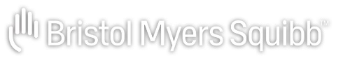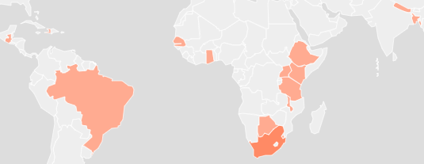

TABLE OF CONTENTS
- BMS programs…………………………………………………………………………..02
- Program distribution by NCDs……………………………………………………..03
- Program distribution by countries………………………………………………04
- Program distribution by focus countries……………………………………. 04
- Program Implementing partners………………………………………………….05
- Program distribution by Strategies …………………………………………….06
- Program distribution by beneficiaries………………………………………….07
- Beneficiary Population………………………………………………………………...08
- People Reached numbers for Continuum of care………………………….09
- People reached numbers based on Indicator groups…………………….10

BMS PROGRAMS

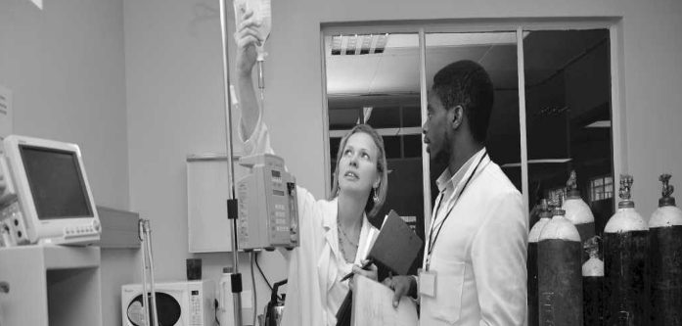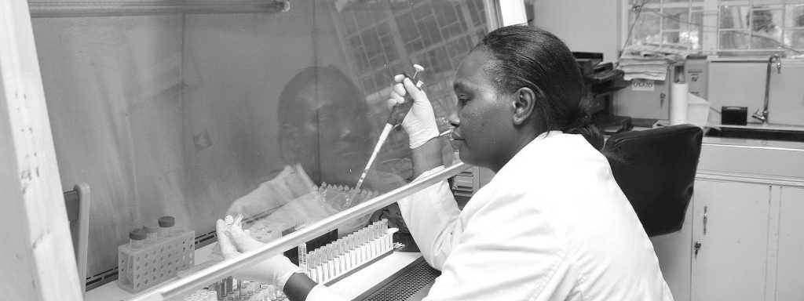
CELGENE CANCER CARE LINKS
CELGENE AMPATH ONCOLOGY PARTNERSHIP


GLOBAL HOPE (AFRICA)
CHILDREN AND MOTHERS PARTNERSHIPS (CHAMPS) INITIATIVE- KENYA


PROJECT ECHO FOR CANCER CARE (SOUTH AFRICA)
PINK RIBBON, RED RIBBON (AFRICA)

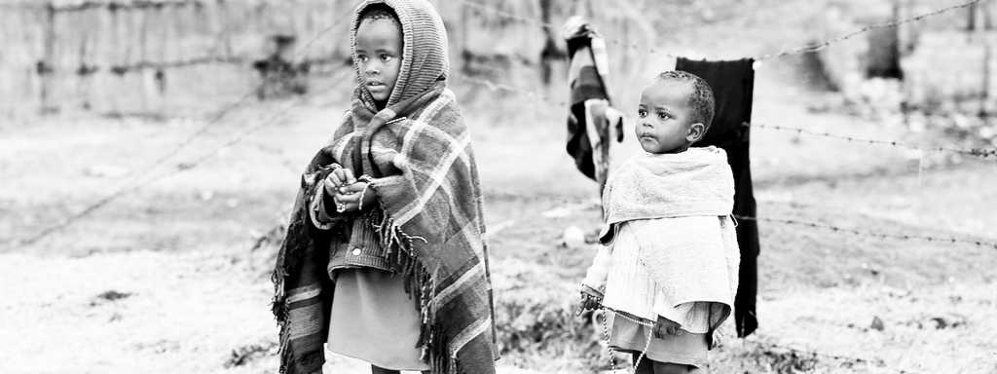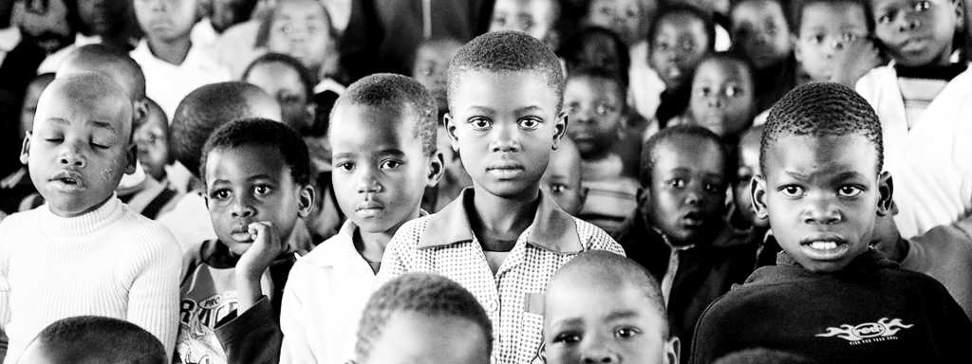
SECURE THE FUTURE- KENYA - ALDORET
SECURE THE FUTURE- GAUTENG PROVINCE, SOUTH AFRICA

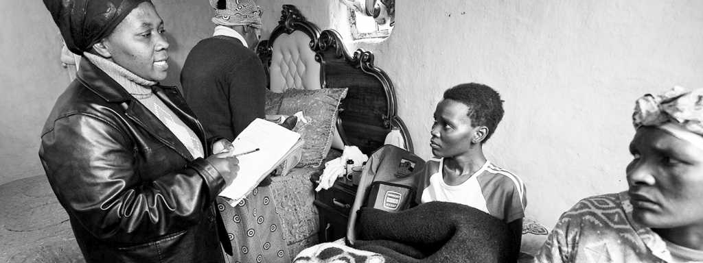
SECURE THE FUTURE- MULTINATIONAL LUNG CANCER CONTROL PROGRAM (MLCCP)
SECURE THE FUTURE- KWAZULU NATAL SOUTH AFRICA
SECURE THE FUTURE- LUNG CANCER IN SWAZILAND

PROGRAM DISTRIBUTION BY NCDS

Quick information
- Programs focus on 4 NCDs Cancers, Diabetes, Cardiovascular diseases and other NCDs.
- No programs reported under Respiratory diseases.
- Most programs focus on Cardiovascular diseases.

PROGRAM DISTRIBUTION BY COUNTRIES

PROGRAM DISTRIBUTION BY FOCUS COUNTRIES

Quick information
- BMS programs are spread over 18 countries.

PROGRAM IMPLEMENTING PARTNERS
BMS collaborates with 27 implementing partners.

PROGRAM DISTRIBUTION BY STRATEGIES

Quick information
- Community Awareness and Linkage to Care is associated with 21 implementing partners.
- Health Service Strengthening is associated with 23 implementing partners.
- Health Service Delivery is associated with 19 implementing partners.
- Price Scheme is associated with 6 implementing partners.
- Supply Chain is associated with 6 implementing partners.
- Regulation and Legislation is associated with 6 implementing partners.

Program distribution by beneficiaries

BENEFICIARY POPULATION

Quick information
Beneficiary population served by BMS is 58,361,190
Reasons why the programs were partially included
Partially For programs active in multiple countries, information on catchment area was not universally available across all countries. In those cases, all available catchment areas were included.
Example: Access and Affordability Initiative (AAI) Cities – catchment area only available for Ghana (included) but not for the Philippines (not included).
Reasons why the programs could not be included
Programs where no catchment area could be determined based on publicly available information.
- Improving Healthy Aging Through A Life Course Approach – Policy changes program
- Increased Access to Cancer Treatments Across Africa, Asia & Latin America - Access and Affordability Program

PEOPLE REACHED NUMBERS FOR CONTINUUM OF CARE

- Latest data reported is from 2017.
- No data reported for 2018 and 2019.
- Data reported only for one program out of six.
- Other stages of continuum of care
- Screening
- Diagnosis
- Treatment
- Long term care

People reached numbers based on Indicator groups

X program reported data for 2017
Y program reported data for 2018

