Creator/Editor account- User manual
FTCI - Best Practices Repository

- Click on Best practice repository and then ‘Submit a best practice’ as shown below
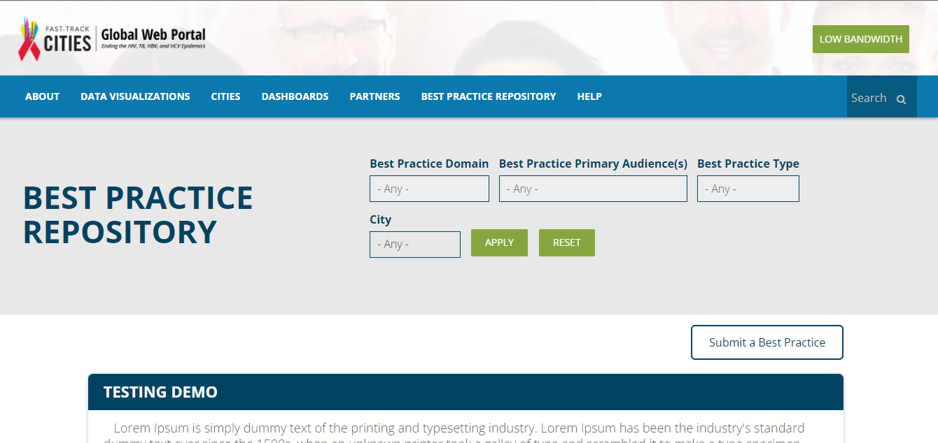
- Enter the credentials in the fields provided and click the ‘Log in’ button.
If you do not have the credentials, you can request for them by clicking on ‘Create a new best practices account’ and enter the details.
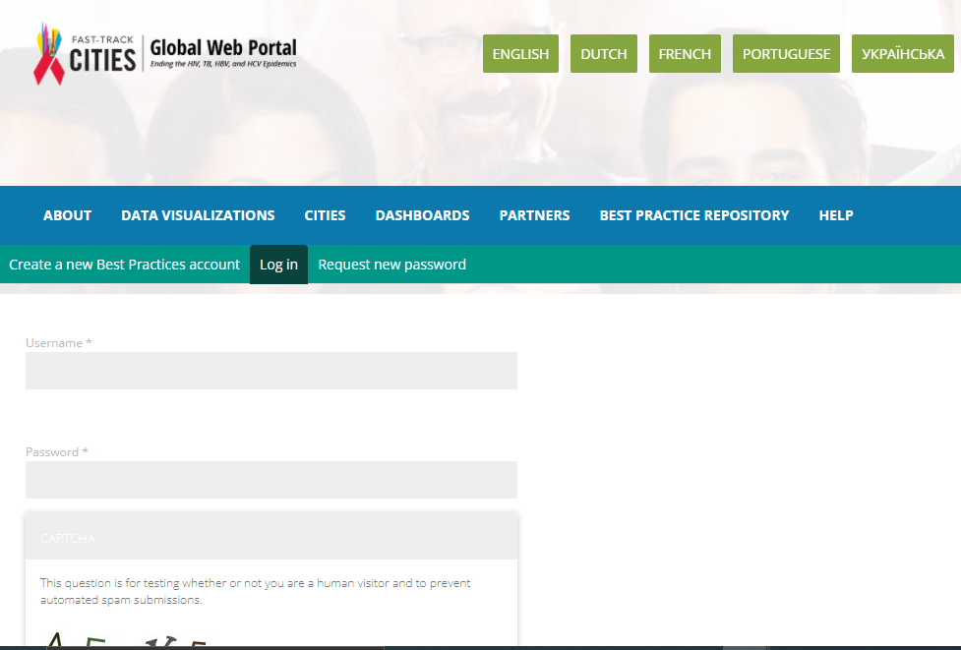

- The user will be directed again to the BPR page. From here, the user can select the ‘Submit a best practice’ or from top left, click on ‘My workbench’ > ‘Create content’ > ‘Best practices’ as shown below –
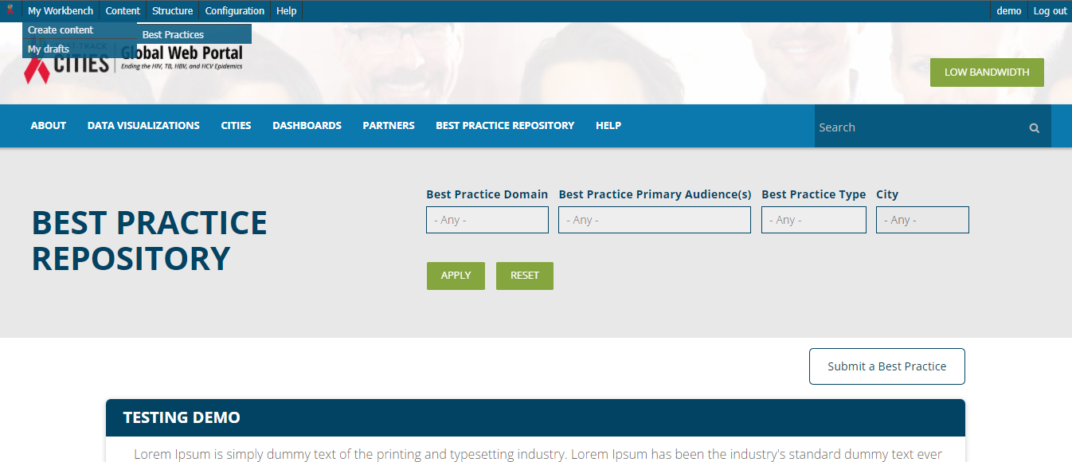

- The user can enter the content details in the fields provided on the display screen –
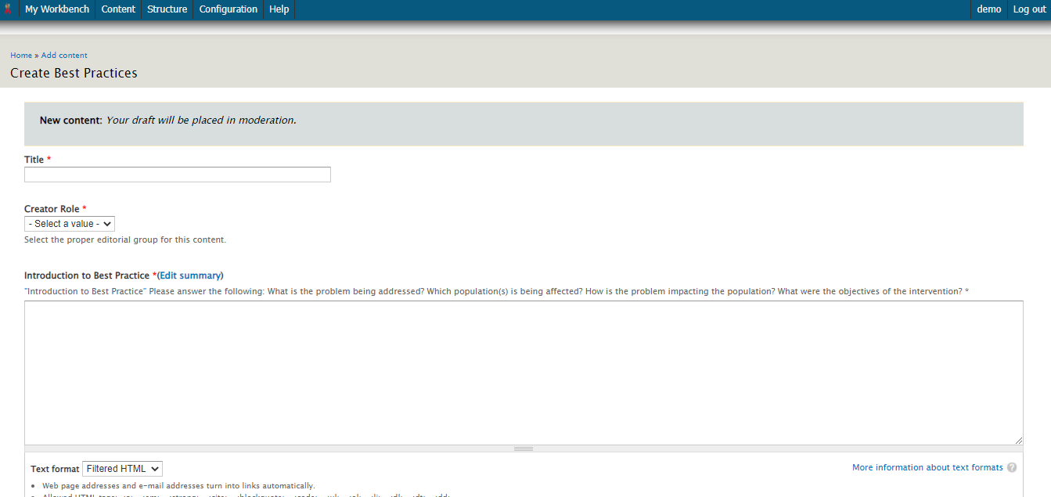

- After entering the details, the user can save this as a draft or directly submit it choosing from the moderation state tab at the end of the screen and thereafter click on SAVE as a final step –
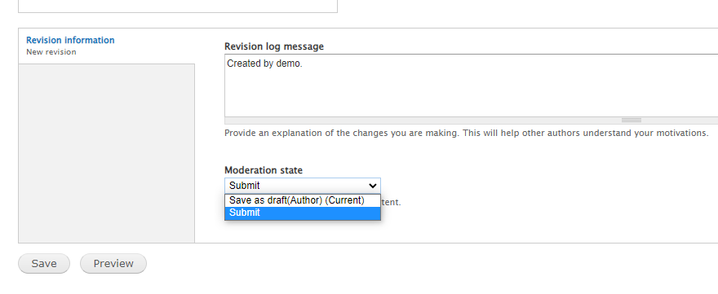

- If ‘save as draft’ is selected, the user can anytime complete the rest of the fields and submit it later. The draft can be accessed from ‘My workbench’ > ‘My drafts’ as shown in step 3 –
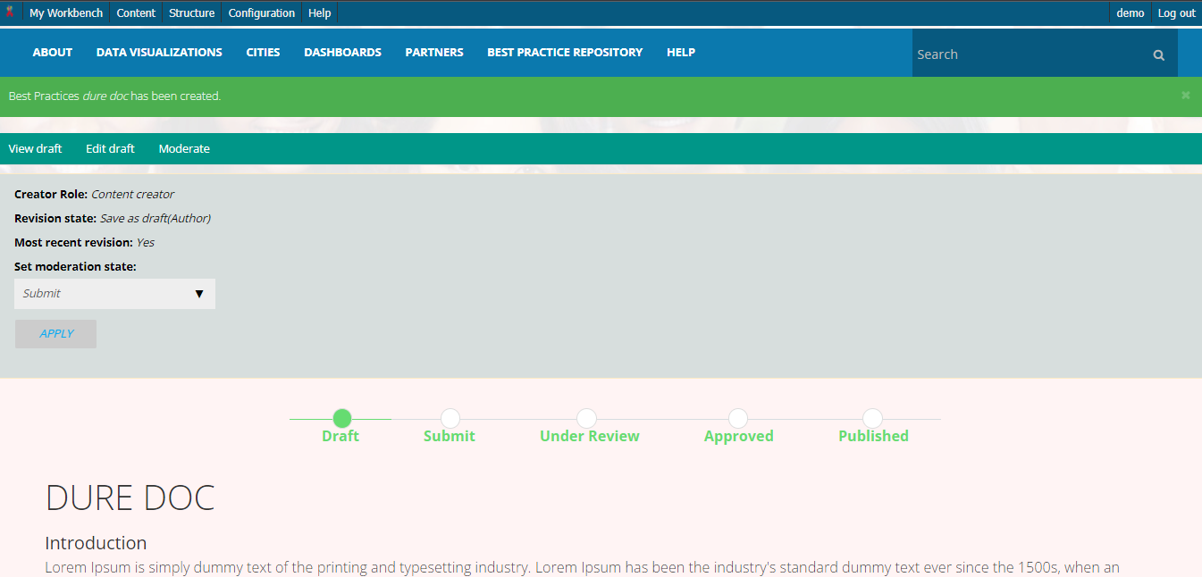

- Once submitted, the following screen will appear and email notifications will be sent accordingly.
